The Inverse Square Law of Light: Key to measuring the intrinsic energy outputs of stars

In the last lecture we learned how to measure the apparent brightness of a star and further learned that this represents the amount of energy that is deposited per square centimeter per second – we call this the flux. Before doing anything quantitative, it is useful to qualitatively consider the following: Suppose we have some light source located at some distance from a detector. Clearly if we move that light source farther away, less energy falls on the detector and the light source would appear to become fainter. Conversely if we move the light source closer to the detector, then the flux would increase and the star would appear to be brighter. What we now seek is a quantitative relation between stellar distance and flux received by a detector. Such a relation exists and is known as the Inverse Square Law.

An Isotropic Radiator

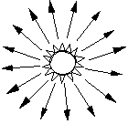
Key to understanding the inverse square law (see also the simulation below) is to realize that a point source of light emission (e.g. a star or a light bulb) emits equal amounts of light in all directions. This is known as an isotropic radiator and can be visualized as shown. Here the arrows show that equal amounts of energy/radiation/photons are emitted in all directions. There is no one preferred direction. Therefore, as you take your hypothetical one square centimeter detector and move it farther and farther away from the star, less energy is received by that detector. This situation is shown below where the same amount of light has to pass through our detectors. At distance r, all the light passes through our 1 sq centimeter detector – but at distance 2r we now require 4 detector elements to contain all that light, so the light passing through each 1 sq centimeter element is ¼ what is was at distance r. At distance 3r we require 9 elements and the light passing through each element is now diminished by 1/9. This means that the flux of light decreases as in the inverse square of the distance between the detector and the source.

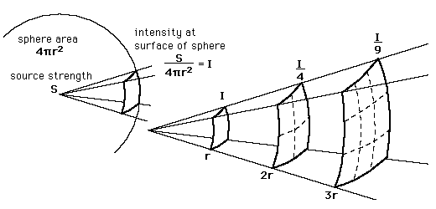

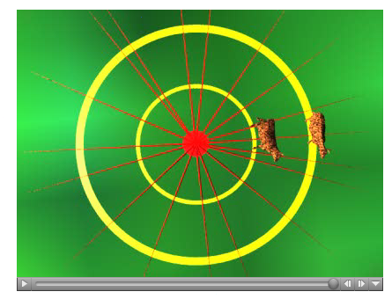

But perhaps a better explanation might involve the use of some cooperative cows, a circle and a cow bomb. The end state of this system is shown where one can see that the inner cow has fallen on the circle of Radius = 1. The cow standing on the circle of Radius = 2 remains upright. There is 4 times as much area in circle 2 than in circle one, therefore the probability of the cow being struck by an isotropic fragment is ¼ of that at position R=2 than at R= 1. Please watch the http://zebu.uoregon.edu/images/cowbomb.mpg animation of this process and then listen to the http://zebu.uoregon.edu/images/cowbomb.au narrative of this process.

Because the surface area of a sphere is 4πR² we can formally state that the flux of a star is given by

Flux = Luminosity / 4πR² where the term Luminosity refers to the intrinsic energy output of the star. Hence if you were to take a star of luminosity = L and move that star 10 times farther away, the flux on the detector would decrease by a factor of 10² (100). So remember the basic scaling is:

Flux goes as 1/D² : Where D is the distance to the light source.

Thus, if you move a standard light bulb twice as far away, the energy that you receive goes down by 2²; that is you receive 1/4 as less energy. It is this simple reason why distant stars appear faint.

Strange as this may sound, most elementary astronomy students never understand this concept and how to apply it. The second homework assignment will give you this opportunity to apply it. To help reinforce this concept you should use the simulator located at http://homework.uoregon.edu/pub/class/2004/flux/

