COLOR AND STELLAR TEMPERATURE

To conclude with this module we will explore, in detail, the way that astronomers can measure the surface temperature of stars directly from stellar color. In turn, stellar color is measured by using different filters and measuring how much stellar flux passes through each filter. The ratio filter flux can be used to make an index which closely matches stellar surface temperature. This will all be tied together through the use of another simulation/measuring device.

Stellar Temperature: When we speak of the temperature of star, it can be confusing. For this course we will distinguish temperature as either being a core temperature or a surface temperature. The core temperature refers to the very interior of the star, the stellar core, in which nuclear reactions are taking place to power it. This temperature is millions to billions of degrees. The core of a star, however, contains only about 10% of the total stellar mass. Surrounding that core is the remaining 90% of the gaseous material. Eventually one reaches the end of that material and that is what we call the “surface of the star”. In technical astronomy terms, this is called the stellar photosphere but we can just refer to it as the surface. The temperature associated with that surface is what we call the surface temperature and it basically represents the region of the star where the light (photons) no longer interact with the stellar matter and are just released into space. That is the part of the star that we therefore actually observe – we can not directly “see” into the interior of the star because it’s obscured by so much dense stellar material. That dense stellar material absorbs radiation and remits it so that the high energy photons created in the center of the star get filtered and down converted to much lower energy photons by the time they actually leave the star. In all cases, Temperature is measured in units of degrees Kelvin (K). The zero point of the Kelvin temperature scale is absolute zero.

Overall, a star is a very hot and dense ball of gas. Any dense object a finite temperature is known as a perfect radiator and emits a particular pattern of radiation. The pattern of radiation given off by a perfect radiator is called Blackbody radiation (because the radiation pattern is independent of what the material is made of). This pattern is characterized by a particular function, called the Planck function, which mathematically is expressed as:

Don't be scared by this formula - it is not necessary to know it. The key parameter in this equation is the temperature. Each temperature corresponds to a unique spectrum of emission. In the interactive activity we will be doing later, you will see how temperature affects the nature of the radiation pattern given off by a blackbody. To a high degree of approximation, stars are blackbody radiators and hence we can use this ideal to describe the pattern of radiation given off. This pattern of radiation is called the Planck curve. This curve is characterized by a wavelength at which the maximum amount of energy or flux or intensity of light is emitted and then a long tail of emission out towards longer wavelengths. An example form of this curve is shown below:

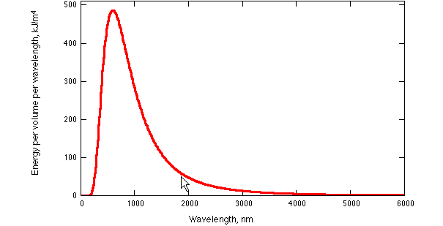

In practice, on divides the wavelength regime into a series of intervals and designs filters to only let light in to a detector within that wavelength interval. Let’s consider the case of blue, green and red filters which are shown below. In the example below, the curve with a temperature of 3000 degrees emits very little light in the blue and therefore would appear to be very red.

Examination of these curves shows a fundamental experimental result. As you go to cooler temperatures, the wavelength at which the maximum amount of energy is emitted shifts to longer wavelengths.

In more quantitative terms, we have this relation:

To reinforce these concepts, we will be using a simulation as shown below. On the left hand side we see an example of the blackbody curve for a radiator (e.g. a star) of temperature 9000 degrees drawn on top of the astronomical UBVRI filter system (U = ultraviolet, B= Blue, V = Visual, R=red, I = near infrared). Clearly the peak energy emitted by this star would be intercepted in the U filter. On the right hand side is the case for T=4500 where clearly the peak energy is now emitted in the Red filter. The flux ratio U/R is clearly much different for T = 9000K than it is for T = 4500K.
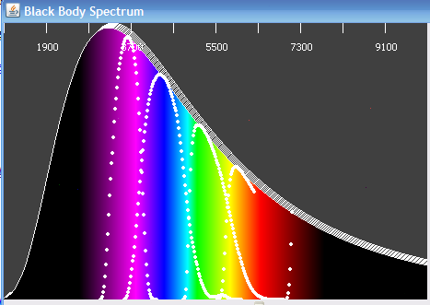
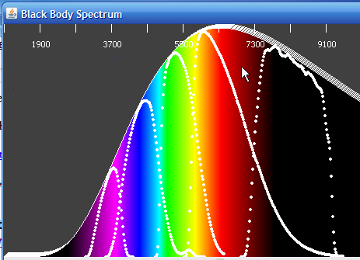

In the examples above, we have been concerned only with emission that occurs in the optical part of the spectrum which roughly covers the wavelength regime of 3500 to 8000 angstroms (or 350 to 800 nanometers). This is an extremely small portion of the total electromagnetic spectrum.
The Optical Spectrum

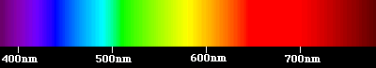

The total electromagnetic spectrum encompasses a very wide range in wavelength/frequency of emitted light (radiation). This is shown below along with a qualitative representation of the wavelengths that correspond to the various kinds of waves.
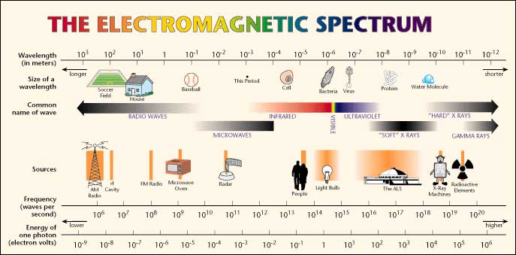

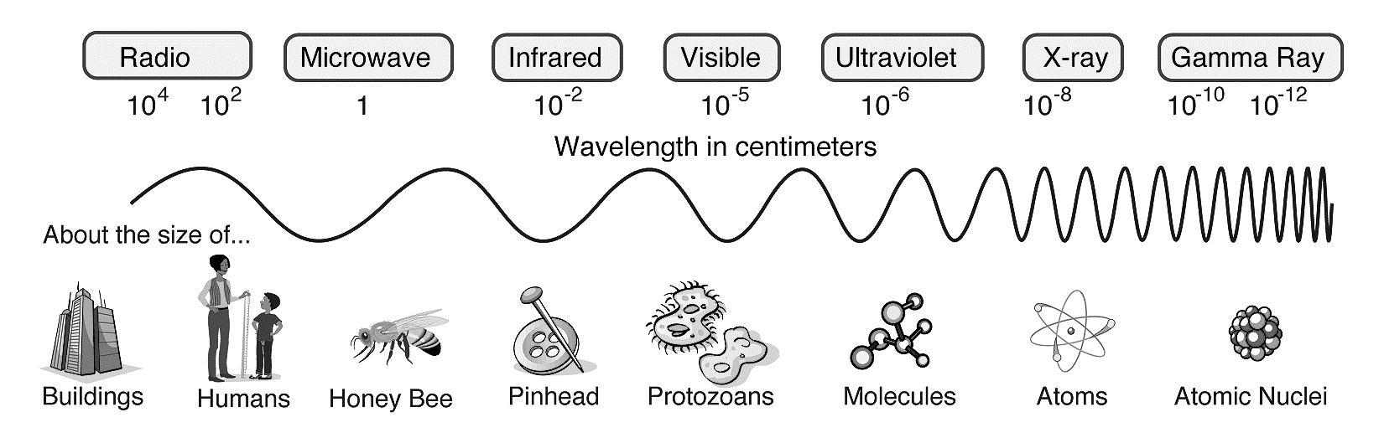

Furthermore, most all of these wavelengths are blocked by the properties of our Atmosphere. In particular it is only Visible/Optical light and Radio waves that are easily transmitted through our atmosphere. In the infrared there are various transparency windows through are atmosphere as well as wavelength regimes that are totally blocked (by water vapor) the atmosphere. Virtually all of the Microwave, Ultraviolet, X-ray and Gamma-Ray regimes are blocked by our atmosphere and hence require satellite observations to access that portion of the spectrum. As we will later learn, the energy of a photon is inversely proportional to its wavelength. Short wavelength photons have very high energy (and hence are a danger to human health – this is what we mean by harmful radiation). In view of that, it’s a good thing that our atmosphere does block out the UV, X-ray and Gamma-Ray photons that otherwise are harmful to life (basically because they have sufficient energy to penetrate and disrupt biological cells). Radio waves, in contrast, have very low energy photons so its perfectly safe for all kinds of wireless transmissions to be occurring on the surface of the earth as such photons easily flow through your body without interacting with anyting.

