The Case of Photon Absorption:

Photon absorption represents the case where an incoming photon is absorbed by an atom and that absorbed energy causes the electron to move to a higher excited state. So, for example, if an electron occupied level E₂ in the atom below and an incoming photon had an energy that was exactly equal to the energy difference between level E₃ and E₂ then that photon would be absorbed (destroyed) and the electron would move from level E₂ to level E₃ .

Again, the critical concept is that absorption only occurs if an incoming photon has exactly the same energy as the energy difference between a lower and an upper energy level and an electron is already occupying the lower energy level. The simplest case is electron occupation of the ground state, since that is where the electron will be most of the time. This electron can be move from the ground state to an excited state by absorption a photon in the following manner:
- Suppose the energy difference between levels E₁ and E₂ is 4 units of energy. Therefore, if an incoming photon has precisely 4 units of energy, that photon can be "absorbed" by the atom, causing the electron to move from energy level E₁ to energy level E₂.
- However, electrons do not like to stay excited and therefore this electron would quickly transition back down to the ground state and therefore emit a photon of energy = 4 units. To the external observer, no net absorption would occur in this case.
- Now let's say the energy difference between levels E₁ and E₃ is 6 units and further, that there is some rule for this atom (called a transition probability), that tells the atom if an electron is in the excited state E₃ it can not fall back directly to the ground state (thereby emitting a photon of energy 6 units) but must first fall back to energy state E₂ (and therefore emit a photon of energy 2 units) and then go from E₂ to E₁ (and emit a photon of energy 4 units).
- For this case then, an external observer would see no photons coming from the source with energy = 6 units. They have all been selectively absorbed by the atom. This produces a lack of photons at a precise wavelength which is then the absorption line (sometimes called a dark line spectrum) observed in the stellar spectrum.

Finally note that if we give "too much" energy to the atom, the electron will be stripped away and there will be no electrons in a bound atomic energy state. This process is known as "ionization" and we will discuss this further later. In the example above, suppose that E₄ is 7 units of energy above the ground state and it’s the highest energy level in this atom. This means that if this atom receives more than 7 units of energy, it will become ionized. Since photon energy is inversely proportional to wavelength and since hot stars radiate more of their energy at short wavelengths, then we expect ionization to occur (easily) in hot stars as most of the emitted photons have energies greater than the ionization energy of the atoms that compose its atmosphere.

Below is a spectrum of a star like our Sun. In a future lecture page you will be measuring features in real stellar spectra. The "dips" in the spectra are due to absorption lines, places in the spectra where photon energy has been removed due to the excitation of an electron from a lower atomic level to an upper one, in the manner described above.

The image below shows an expanded version of the spectrum of relatively cool stars (K stars – the designation as a K star will become apparent later when we discuss spectral types). In general, cool stars have lots of low energy photons that are easily absorbed and hence cool stars have many spectral features associated with them – some of these you will measure later in some interactive exercises. The myriad of features that you observe, especially between 4000 and 6000 angstroms, are all absorption lines arising from different elements. The strong, narrow feature at 5885 angstroms is due to the element of Sodium and this is a characteristic of all spectral type K Stars.


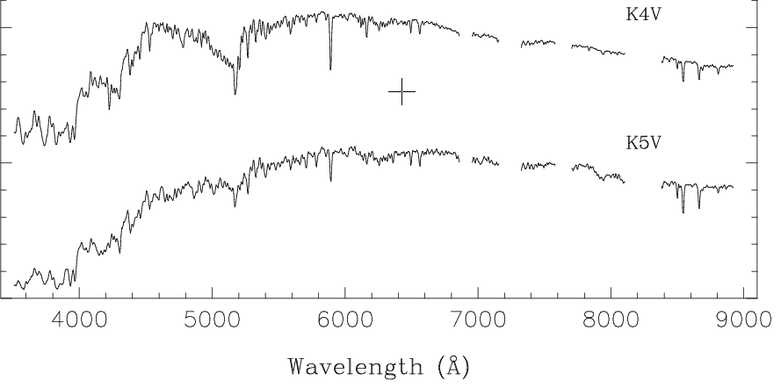

The properties of atomic energy levels then lead to the important physics stated in the box below:

Each Chemical Element has a unique set of atomic energy levels and therefore has a unique spectrum

Hence Sodium and only Sodium has a feature at 5885 angstroms. Other elements may have features at approximately this wavelength, but only Sodium is at exactly this wavelength. This is precisely why spectroscopy of stars has to be done a sufficiently high resolution so that the wavelengths of the spectral features can be measured with sufficient accuracy to determine which chemical element is responsible for the observed absorption feature at that wavelength.

Visualized summary of the formation of an absorption line: http://opencourse.uoregon.edu/pub/astr122/pod3.pps

