Classifying the Spectra of Stars:

Another Internet Resource on this subject: Overview of Spectral Classification

The spectral classification system is mostly a historical relic but it’s still widely employed. Depending upon the chemical composition and atmospheric temperatures of stars, different patterns of spectral lines and different strengths of spectral lines for a given element will appear.

Individual stars which show similar patterns and strength of spectral features can be regarded as physically the same kind of star. As a result of this, it’s possible to develop a classification system (see table below) that incorporates "families" of spectral features together into a unique spectral type of star.

The spectral sequence is therefore a temperature sequence, with O stars being the hottest and M stars being the coolest. The general characteristics of stars of different spectral type are summarized below.
Type | Color | Approximate Surface Temperature | Main Characteristics
O | Blue | > 25,000 K | Singly ionized helium lines either in emission or absorption. Strong ultraviolet continuum. No hydrogen lines; No calcium or sodium.
B | Blue | 11,000 - 25,000 | Neutral helium lines in absorption. Very week hydrogen lines
A | Blue | 7,500 - 11,000 | Hydrogen lines at maximum strength for A0 stars, decreasing thereafter.
F | Blue to White | 6,000 - 7,500 | Hydrogen lines are present but weaker than in A stars; Lines of Calcium start to be come strong as well as Sodium.
G | White to Yellow | 5,000 - 6,000 | Solar-type spectra. Absorption lines of neutral metallic atoms and ions (e.g. once-ionized calcium) grow in strength.
K | Orange to Red | 3,500 - 5,000 | Metallic lines dominate. Weak blue continuum. Sodium is very strong.
M | Red | < 3,500 | Molecular bands of titanium oxide noticeable. Band heads are very "thick" absorption lines that break up the spectrum.

Subtypes:

Within each of these seven broad categories, there are subclasses numbered 0 to 9. A star midway through the range between F0 and G0 would be an F5 type star. The Sun is a G2 type star. In addition to subtypes, there is also a luminosity class, designated by roman numerals from I to V. Class V stars are main sequence stars (which we will study later) and are the only ones we will concern ourselves with. While the simulation does have data for class III stars (giant stars) we will not make use of that data.

The following guide is a qualitative guide to how to classify stars based on various line strengths from various elements and it is the method we will employ in classification.

Morgan's Rules of Spectral Classification

Hydrogen lines are strongest in A stars, but are present in B and F stars. The Letter naming scheme for spectral types is a historical accident. It makes no real sense, so don't worry about it.

The calcium doublet (3934, 3963 angstroms) is strongest in G stars (but appears more weak in F and K stars); Hydrogen lines are present in G stars but are weak. Hydrogen lines are somewhat stronger in F stars than G stars, particularly the line at 6563 angstroms. The Magnesium feature at 5175 angstroms is always stronger in G stars than in F stars.

The sodium feature at 5885 angstroms is strongest in K stars. There is also a strong Magnesium feature at 5175 angstroms that is usually somewhat broad and shallow. The Calcium doublet is typically weaker in K stars compared to G stars.

M-stars are very cool and typically have broad features. They usually have strong sodium but it’s broader than it is in a K star. M-stars are a complicated mess that often has very large areas of absorption due to molecules in their atmospheres. We will not be dealing with this spectral type.

Now we will measure actual stellar spectra and determine the ratio of hydrogen line strengths to Calcium and Sodium line strengths. When we make measurements of the "strength of a line" or an absorption feature in a stellar spectrum, we will use a feature called The Equivalent Width.

In an absorption line less energy is transported than in the neighboring continuum. The continuum represents the area where the pure blackbody emission spectrum of the star appears, unaffected by the presence of spectral features due to absorption. The amount of this energy deficit is proportional to the approximate triangular area of the line. Now we convert this triangular area to a rectangle with the height of actual continuum. The width of this rectangle is the equivalent width and is measured in units of angstroms. It is a relative measure: a star with say a hydrogen line EW of 4 angstroms and a Calcium line equivalent width of 2 angstroms could then be classified as having hydrogen lines twice as strong as calcium lines. This would likely make this an A star.

The concept of equivalent width is graphically represented here:

We will now make equivalent width measurements on a library of stars using real data and a real measuring instrument. Follow the procedure below, exactly:

1. http://homework.uoregon.edu/pub/class/122/hw3.wmv - watch the video tutorial on how to use the simulation and how to make the measurements. Pay particular attention to the part about setting the window for the spectral line and setting the reference level that determines the equivalent width. Because there is error associated with this, a range of values is specified in the table below.

2. http://homework.uoregon.edu:8080/spectra/spectra.jnlp - download the simulation but only after watching the tutorial

3. You will be measuring the equivalent widths of the following lines:

(H) Hydrogen = 4340 angstrom line

(He) Helium = 4472 Angstrom line

(Ca) Calcium = 3934 Angstrom Line

(Na) Sodium = 5885 Angstrom Line

(Mg) Magnesium = 5175 Angstrom Line (but its broad so its over the general range 5170—5195 angstroms)

Select the following stars in which to make the measurement:

O7-BOV

B3-4V

A1-3V

F6-7V

G1-2V

K4V

Note that in some cases for some stars the absorption line will be too weak to measure.

When you’re done, your compare your results to those tabulated below to see if you’re on the right track in making the measurements correctly. .
Type | 4340  Hydrogen | 4472  Helium | 3934  Calcium | 5885  Sodium | 5175  Magnesium
O7-B0 V | 3.5 – 4.2 | 0.0 – 0.5 | -------- | 1.5 – 2.0 | -------
B3-4 V | 5.0 - 7.0 | 0.8 – 1.2 | -------- | 0.0 – 0.5 | -------
A1-3 V | 18--20 | ---------- | 1.5 - 2.5* | 0.5--1 | 0.5-1
F6-7 V | 3.0 – 3.5 | ---------- | 6 – 8** | 0.5 -1 | --------
G1-2 V | 0.6—0.8 | --- ---- | 9 -- 11 | --------*** | 2.5 – 3.0
K4 V | --- | --- | 10 -- 12 | 5-6 | 7-10****

*this one is very challenging to measure – do not confuse the Calcium line at 3970 angstroms with the very near hydrogen line at 3955 angstroms – at the resolution of this spectral data, those two features kind of blend in to one another.

** Multiple lines near this feature

***The spectral feature there is another sodium line at 5895 but it is not the 5885 line we have been measuring.

****Complicated structure

Advanced Material:

This material is generally outside the scope of an introductory class but we include it here as an example of the advanced features of the simulation. In addition, some of this material is relevant to gaining further insight into how astronomers actually measure the strength of spectral features.

Below is a spectrum of a real F star and we are interested in measuring the strength of the Hydrogen line at 4861 angstroms, indicated by the vertical line that goes through the feature.

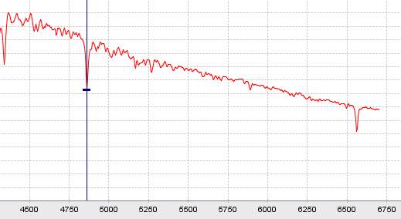

Notice that there is an overall slope to the spectrum – it is rising toward short wavelengths. This slope is a direct indication of the temperature of that star since the slope is basically determined by the blackbody curve that exists for that temperature (in this case about 8500 K). Since the shape of the continuum radiation is known (remember, the continuum refers to the overall shape of the spectrum as unmarred by absorption lines) then in principle we can subtract it out by fitting a blackbody curve to the data and adjusting the temperature. The simulation has this capability under advanced features where you are allowed to adjust the temperature of the blackbody until the spectral baseline becomes flat. In this case, using a blackbody temperature of 8500 produces this representation of the data:

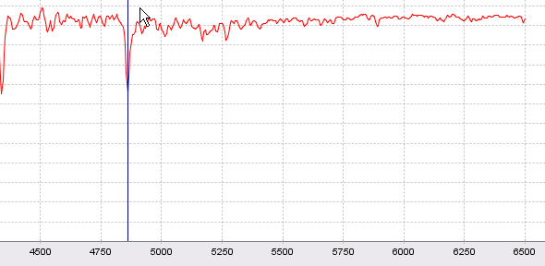

Now you can see that the spectra has been “flattened” making it some what easier to measure. Once you have a flattened spectrum you can fit the continuum within the window limits as shown here:

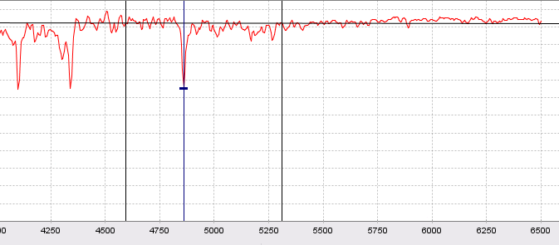

That relatively flat line between the windows then provides you an indication of where the actual continuum level lies with respect to determining the equivalent width. Zooming in on the feature and narrowing the window and checking integration in the advance feature set now reveals the area of the spectra that your determining.

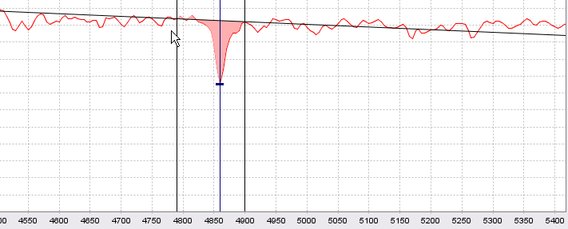

It is this area (red shaded region above) that you’re trying to represent by the notion of equivalent width. That final step is shown here – the area of the red curve and the area of the black rectangle are identical and the black rectangle is known as the equivalent width. The height of the rectangle is automatically determined by the continuum level and this is the principle reason why its advantageous to flatten the spectra.

