Energy Generation in Stars

E = mc²

The above famous equation basically specifies a fundamental condition of our Universe. Mass can be converted to energy and energy can be converted to mass. The process of mass conversion to energy is known as thermonuclear fusion and it requires very high temperatures. Fusion means the heavier elements are built up from light elements. We can not yet achieve such sustained high temperature in the lab on earth, but stars can easily achieve this due to their tremendous masses that require high temperatures for stabilization against gravitational collapse.

At such high temperatures conditions are favorable for the onset of fusion and the generation of energy from mass conversion to energy. Remember that, the speed of light is a large number which means that c ² is absolutely gigantic. Thus, a relatively small amount of mass can provide a great deal of energy. In simple terms, a star is a big ball of gas that is sufficiently hot in its core that thermonuclear fusion is occurring.

But how does the ball of gas get hot in the first place. This is because of the interplay between http://opencourse.uoregon.edu/pub/astr122/pg.pps pressure and gravity. The internal gas pressure is attempting to expand and dissipate our ball of gas, while the self-gravity of the gas (due to its mass) is trying to collapse the ball. If pressure exceeds gravity, then no star will every form and the gas will simply dissipate. However, if force from self-gravity exceeds the internal pressure support, the ball of gas starts to collapse. The key physical concept here is that as the gas collapses it gets hotter – as the gas gets hotter, it’s internal pressure increases and therefore starts to more strongly work against the gravitational collapse of the gas. Eventually there will come a point of stabilization (review the PowerPoint animation on this) in which the internal pressure force exactly balances the self-gravity of the star. The star is then stabilized against further collapse and its best characterized by a core + envelope structure:

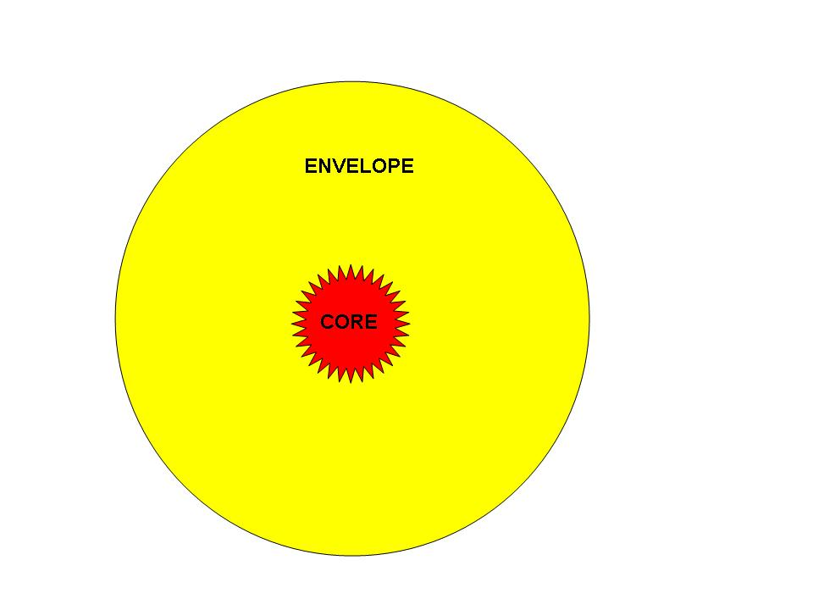

A ball of hydrogen collapses until pressure from the hot core stabilizes the star against further collapse. Each mass (which determines the amount of self-gravity) requires a unique core temperature for stabilization. Thus a 2 solar mass ball of as will require a higher core temperature for stabilization than a 1 solar mass ball of gas, which in turn is higher than for a 0.1 solar mass ball of gas. This unique relationship between core temperature and stellar mass is the physics that drives the observed mass-luminosity relationship for main sequence stars as previously discussed. When this point os pressure stabilization is reached, the star is now a main sequence star and is capable of fusing hydrogen as its energy source, provided the core is hot enough.

Hydrogen Fusion:

A hydrogen nucleus is consists of a single proton. For fusion to occur, the following conditions have to be met:

When two protons fuse (i.e. the first step of the proton-proton chain) they have to have sufficient kinetic energy so as to overcome the mutual electrostatic repulsion (because they have positive charges). That is, their like charges will tend to repel one another. However, if the protons can become sufficiently close to one another, another force, the Strong Force, will take over and bind the two nuclei together. The strong force is the force that holds together all the protons that exist in various atomic nuclei – to activate this force requires the nuclei to essentially penetrate each other during a collision.

To attain sufficient kinetic energy for a penetrating collosion, the protons must be moving very fast and therefore the gas temperature has to be very high, at least 5 million K. In the case of the sun, its core temperature is approximately 15 million degrees.

This means there is some minimum mass for fusion to occur. This minimum mass is about 10% the mass of the sun. Balls of hydrogen with masses less than 0.1 solar masses, therefore, can never generate enough weight on the core to in turn generate a temperature of 5 million degrees for stabilization against gravitational collapse. Therefore, such low mass objects will never become a star. Jupiter, by the way, has a mass of 1/1000 the mass of the sun and therefore never had a chance to be powered by nuclear fusion (i.e. a star).

The minimum temperature for the fusion of Helium is much higher than for hydrogen because each Helium nucleus has two protons (not one), so the mutual electrostatic repulsion requires more energy to overcome and this requires higher temperature. Similarly, the fusion of Carbon would require a higher temperature than Helium, and so on. This situation will become important later on in helping to drive stellar evolution.

Hence as along as the stellar core as a temperature of 5 million degrees, the ball of gas will become a star. In this way, all main sequence stars, regardless of their mass, fuse hydrogen in their cores. All main sequence stars are stable (P=G) and their core is at constant temperature.

The proton-proton chain:

Fusion occurs via the proton-proton chain (see the animations) as hydrogen turns into helium in the stellar core. The various steps of the proton-proton chain are shown below. At the end of the process two free protons remain to continue the cycle.

Step 1: Two protons have a penetrating collision: 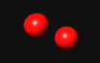

Step 2: 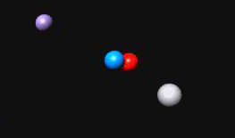After the protons collide and stick one of them decays into a neutron (there is not such thing in nature as an element with only 2 protons in its nucleus and no neutrons). This new nucleus of a proton (p) + neutron (n) is an isotope of Hydrogen known as deuterium. Some necessary atomic debris (see more below) is also created in the form of a positron and a neutrino. A positron is an anti-electron and a form of anti-matter.

Step 3: 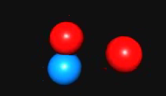 The (pn) nucleus is now going to fuse with another free proton.

Step 4: 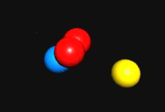 A photon (high energy gamma ray) is given off through this reaction and a new nucleus with 2 protons and one neutron now exists. Thus we have formed a new element, Helium. This particular form of Helium has only one neutron in its nucleus and this is known as ³He.

Step 5: 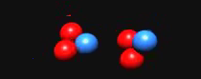 In this step, 2 ³He come together to form one ⁴He nucleus (2 protons and 2 neutrons).

Step 6: 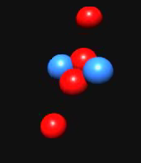 The two now liberated protons are now free to renew the chain beginning from step 1.

The net result of this 6 step fusion reaction is to convert Hydrogen (a single proton) to ⁴Helium (two protons and two neutrons). The mass of one Helium nucleus is slightly smaller than the mass of 4 protons. That mass difference, multiplied by c², has been converted to energy. This mass difference is very small and amounts to 0.7%. Thus the efficiency of energy generation in the sun is incredibly low, only 0.7% (or 0.007).

In the first step of the proton-proton chain, anti-matter is spontaneously created. In the second step of the chain, energy is released (in the form of high energy photons). These photons eventually escape the surface of the sun, giving us sunlight.

Okay, so why is anti-matter created?

In any particle reaction, three things must be conserved:

Charge

Baryon Number

Lepton Number

A baryon is a "heavy" particle which is made up of quarks. A proton and a neutron are baryons. A proton has a baryon number of +1; an anti-proton has a baryon number of -1. If a particle is not a baryon, it has a baryon number = 0. A lepton is a light particle which is not made up of quarks. Electrons and neutrinos are leptons. Whatever the total charge, baryon number and lepton number was before the reaction, the sum of the charges, baryon numbers and lepton numbers of the reaction products has to be the same after the reaction.

A good example to show why anti-matter can be spontaneously created is the decay of the neutron.

Let’s now examine how these rules come into play for the very first part of the proton-proton cycle, the fusion of two protons to one Deuterium nucleus:

Prior to the reaction the total Charge Number (CN), Baryon Number (BN) and Lepton Number (LN) of two proton is :

CN = +2

BN = +2

LN = 0

However these numbers for a Deuterium nucleus are

CN = +1

BN = +2

LN = 0

Oh oh - we now have non-conserved charge in this reaction. To make sure that the after reaction CN is +2 a position was spontaneously created. A position is an anti-electron and therefore has LN = -1. Oh oh again, because LN has to be zero. So in the spontaneous act of creating positive charge to maintain CN =+2, we now have unbalanced LN. Oh crap, we now must create another particle and that particle must have

CN = 0, BN =0, LN = +1

Such a particle exists and is called a neutrino. In this manner, two initial particles (e.g. the two protons) end up being converted in 3 new particles (A Deuterium nucleus, a positron and a neutrino).

Key Points:
- Main sequence stars are stars that are stable and derive energy from hydrogen fusion in their cores. Each mass has a unique core temperature required for stabilization. This will turn out to drive much of stellar evolution via the following concepts:
- The fusion rate in a star, which determines its total energy output is extremely sensitive to the core temperature. Small changes in core temperature produce large changes in the nuclear reaction rate and thus large changes in the overall energy output of the star (e.g. its Luminosity).

- Stellar evolution is governed by a constant battle between Pressure (P) and Gravity (G). Keep in mind that a star is just a big ball of gas. Three things can happen:

- P=G: the star is stable; energy generation is occurring in its core This provides gas pressure which prevents the collapse of the star. Each mass has a unique value of P to stabilize this which produces a unique core temperature. Thus the core temperature of a 2 solar mass star is larger than for a 1 solar mass star. Higher core temperature produces a much higher fusion rate in turn, this produces a shorter lifetime (as explained below)

- P > G: Pressure exceeds gravity and the star (ball of gas) expands and it cools.

- G > P: Gravity exceeds pressure; The star (ball of gas) collapses and it heats.

- When a star is generating energy in its core, it is stable (P=G). Main sequence stars are therefore stable.

- If the star is not generating energy in its core, it is unstable and either must expand or collapse. The loss of a core source of energy generation is what triggers the next phase of stellar evolution.

Main sequence lifetimes:
The hydrogen burning lifetime of a star depends upon the mass of fuel (mass of stellar core) that is has to burn and the rate at which that fuel is burned (this is the luminosity). For the sun, this lifetime works out to 10 billion years via the following steps:

- Mass of fuel = mass of hydrogen in the core of the sun = 10% the mass of the sun = (0.1) * (2 x 10³³ grams) = 2 x 10³² grams.

- The total available energy in this fuel is mc² * efficiency of the energy conversion: = 1.2 x 10⁵¹ ergs of energy.

- Rate of fuel usage = Luminosity = 4 x 10³³ ergs/ sec

- The lifetime of exhausting 1.2 x 10⁵¹ ergs of energy of available energy is then (1.2 x 10⁵¹ ergs of energy)/ 4 x 10³³ ergs/ sec = 3.15 x 10¹⁷ seconds which is about 10 billion years.

Thus for a star like the sun, it will take about 10 billion years for the core hydrogen to be fully converted to Helium. We are about 1/2 way through that process now.

Overall the evolutionary timescale of main sequence stars is entirely driven by stellar mass in the sense that massive stars evolve much more quickly than low mass stars. This can be understood from the mass-luminosity relationship as the lifetime of the star essentially is M/L.
So while a 10 solar mass stars has 10 times more available fuel/energy content it burns that fuel up 10,000 times faster and therefore has a lifetime 1/1000 that of the sun, or 10 million years. The rapid evolutionary timescale of massive stars is the reason that life exists in the Universe and that will become clear after the next few modules.

