Stellar Clusters and Star Formation:

In simple terms, star formation proceeds in the manner previously discussed – namely a ball of gas collapsed under its own self-gravity until it’s stabilized by sufficient internal pressure. At that point it is a hydrogen fusing main sequence star. However, over the last 25 years we have learned and observed that the actual process of the formation individual stars of considerably more complicated than this simple collapse picture suggest. However, the gravitational collapse model still provides the right physical framework to discuss star formation in more general terms other than the specific formation of an individual star. For instance, again as previously established, collapse occurs when self-gravity exceeds internal pressure. However, the interstellar medium (ISM) (where stars form from clouds of gas and dust) in our Galaxy, while quite low density, is generally fairly warm (about 6000K) as it’s heated by already existing stars. Thus, if you simply place a one solar mass cloud of hydrogen into this warm ISM, there will be vastly insufficient amounts of self gravity to over come the internal pressure of a 5000 K 1 solar mass cloud and that one solar mass of cloud will simply dissipate into the general ISM. We thus arrive at a very important physical condition and statement:

Under standard ISM conditions, the minimum required mass for a gas cloud to collapse under its own self gravity is 10,000 to 100,000 solar masses.

Now this does not mean a single star forms, of mass 10,000 or 100,000 solar masses but rather it means that a bunch of stars form together within a larger, gravitational collapsing meta structure. As the meta-structure collapsed individual parts of it being to fragment into higher density clouds, and those can then collapse into individual stars. Similar fragmentation in other parts of the cloud collapse into more stars and the end result is the formation of a few 100 to few thousand stars pretty much all at once within one very large cloud of gas. This is the formation of a stellar cluster (examples shown below)

Often times, for newly formed clusters, there will be lots of gas and dust left over from the formation process and the individual stars will appear still surrounded by their own dust cocoons. The complex network of filaments of glowing gas (which are ionized by the hot newly formed stars, and dark dust regions, represent the embryonic material out of which the stars in the cluster formed.

http://www.nasa.gov/images/content/139974main_image_feature_476_ys_4.jpg

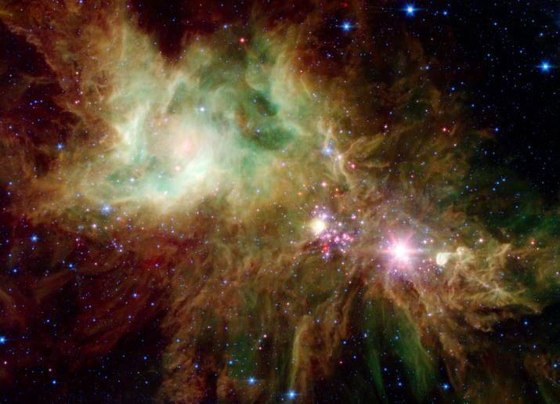

The kind of stellar cluster that forms in this way is called an open cluster – because the stars are that formed are not really gravitationally bound to one another and eventually they will drift apart and the cluster will be no more. This usually takes a few million years. A typical open cluster is 50 light years or less in diameter. The stars within an open cluster are not too closely packed, typically being spaced about 2 light years apart. It is estimated that there are 20,000 open clusters within our galaxy. An example of an open cluster that has emerged entirely from its gaseous cocoon is shown below:

Open Clusters are very useful ``laboratories'' for testing our theories of stellar evolution.

Laboratories are generally thought of as places where scientists can run controlled experiments to test their hypotheses and theories. The galaxy has helped us out to some extent by creating stars in clusters, instead of creating them one by one in random places, at random times, under wildly varying conditions of temperature, density, and chemical composition.

Stars in a cluster formed at the same time, in the same molecular cloud. Therefore, stars in a cluster

have the physical same age,

had the same initial chemical composition,

and are at roughly the same distance from Earth.

The fact that all the stars in a cluster are at the same distance is a great convenience. If two stars in a cluster have different apparent brightness, it must be because they have different intrinsic brightness. We don't have to undertake the tedious chore of determining the individual distance to each of the many stars in a cluster.)

Thus, when stars form within a cluster, they differ only in their mass. The more massive stars evolve more rapidly, so to find the AGE of a cluster of stars, we need merely determine the mass of the stars which have just now exhausted the hydrogen in their cores and are turning into red giants. This can be understood with the help of the following table which shows the relation between mass, luminosity and hydrogen burning lifetime for main sequence stars.

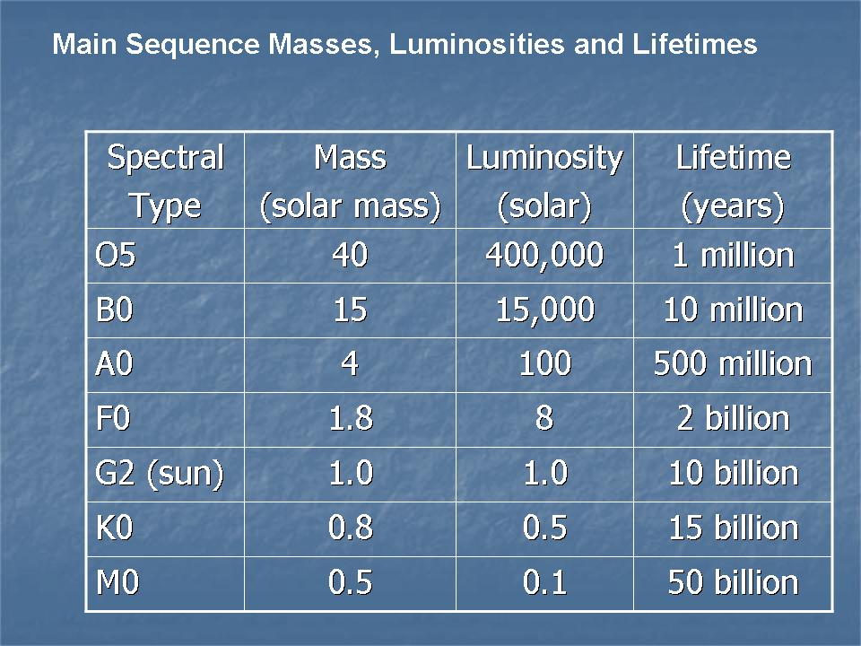

With respect to the values listed in the table, suppose that we have a stellar cluster which is 2 billion years old. In that cluster we would therefore expect not to find any main sequence stars that are more massive than 1.8 solar masses or equivalently no main sequence stars that are hotter than spectral type F0. If the cluster were only 500 million years old, then we would expect stars as massive as 4 solar masses and as hot as A0 to still be on the main sequence (i.e. the cluster is not yet old enough for these stars to have exhausted their hydrogen).

Hence, if we make an HR diagram for a moderately old stellar cluster, we should see the various evolutionary phases (Red Giants, white dwarfs) represented while a very young cluster would not yet show these evolutionary phases. This concept is summarized in the following visualization http://opencourse.uoregon.edu/pub/astr122/hrsc.pps

In more general terms, a young cluster would still contain many, hot, bright, blue upper main sequence stars and in an older cluster, those bright, blue stars would not be there. This means that the overall color of a cluster, which reflects the ratio of blue to red stars, is a rough indicator of its age. Clusters of a few million years old would appear blue (have a B-V color index somewhere in the range 0.0 – 0.4) while clusters of a few billion years would appear redder (having a B-V color index of 0.7-1). Measurements in our galaxy indicate that the youngest open clusters are only 1 million years old (indicating that our Galaxy is still forming stars) while the oldest open clusters are about 4 billion years old. Those older clusters are relatively massive so that the cluster stars, in this case, are gravitationally bound to one another. Most open stellar clusters are not sufficiently massive to bind the stars together and the stars drift free of the cluster over a timescale of a billion years or so.

