Post Main Sequence Evolution:

When the core of the main sequence star becomes pure helium, the temperature will be too low for helium fusion to occur. Helium requires a higher temperature because each helium nucleus contains 2 protons – thus the mutual electrostatic repulsion of 2 Helium nuclei is twice as big as two hydrogen nuclei so more kinetic energy (i.e. higher core temperature) is required for 2 Helium nuclei to have a deep penetration collision and bind together. So at this point, core energy generation now ceases. Without a source of energy, the stellar core no longer has a source of internal pressure to balance gravity and the core begins to collapse and HEAT. The core will continue to collapse and heat until it reaches roughly 100 million K and Helium fusion begins. But before the onset of Helium core fusion, something interesting happens to the star.

As the core collapses and heats, some of this heat is transferred to an annular region around the core which begins to fuse. This is known as hydrogen shell burning. Fusion in this shell then supplies gas pressure which causes both the envelope of the star to expand and the core to collapse even faster. The core + shell + envelope structure of the star now looks like this:

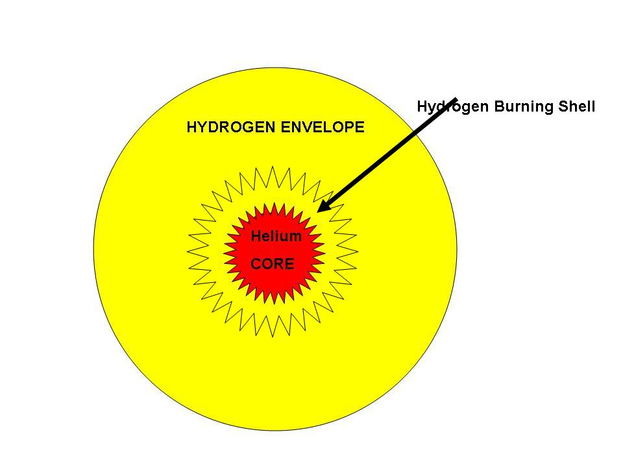

As the core continues to collapse the shell gets hotter and hotter and, in fact, exceeds the previous temperature that held for the hydrogen burning core. Thus the hydrogen burning rate in the shell continues to increase and the star outputs more energy (its luminosity increases). The shell burning source also provides additional Pressure which causes the outer part of the star to expand and cool. The star is now on the Red Giant Branch its luminosity is increasing and its surface temperature is decreasing as a result of the expansion. This sequence roughly looks the following:

http://opencourse.uoregon.edu/pub/astr122/se1.pps

Eventually the core will become hot enough for the fusion of helium into carbon via the process of three helium nuclei (helium nuclei are also called alpha particles) into one Carbon nucleus. Note that the fusion of two Helium nuclei to produce Boron-8 does not happen as Boron-8 is a very unstable nucleus and decays. Energy is then generated because the mass of three helium nuclei is larger than the mass of a Carbon nucleus and that excess mass (multiplied by c²) is transformed to energy. The basic steps of this triple-alpha process are two fold:

Step 1: 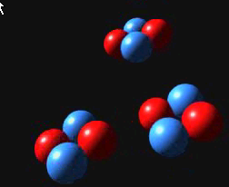 Three Helium nuclei come together

Step 2: 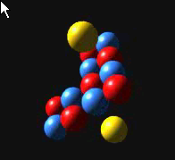 The three alpha particles fuse into one Carbon nucleus (6 protons + 6 neutrons) and two high energy photons are created.

Step 3: Due to all the Helium nuclei available in the core, some ¹²C captures a Helium nucleus to make ¹⁶Oxygen.

The star is once again stable. It has core energy generation and P=G; The star is now a Red Giant and its radius is 100 -- 1000 times larger than when it was a main sequence star.

Now what happens?

As the helium core turns to carbon, the star once again finds itself in a state where the core temperature is too cool to fuse carbon. The core then collapses and heats in the same manner as occurred when core hydrogen was exhausted.

This heat is again transferred to shells around the star but in this case there is a double shell source of both hydrogen and helium burning. Instead of producing a further expansion and even more cooling of the envelope, the resulting pressure from both shell sources is so great that the outer layers of the star are simply driven away exposing the hot core which is now made up of carbon plus a little oxygen.

In fact, up to 90% of the initial mass of the star can be lost this way. So you could start out with a 5 solar mass star and end up with just a 0.5 solar mass core. The amount of actual mass loss varies considerably from star to star - in general more massive stars loose a greater percentage of their total mass in this evolution stage.

The appearance of this star is now rather strange. The former stellar envelope is well separated from the rest of the star due to this stellar wind blowing off the outer layers. As these layers are removed from the star, we can see deeper and deeper in to the star. Moreover, the hot nature of the now exposed core produces lots of ionization radiation that ionizes the gas and causes it to glow. The star now looks like this:

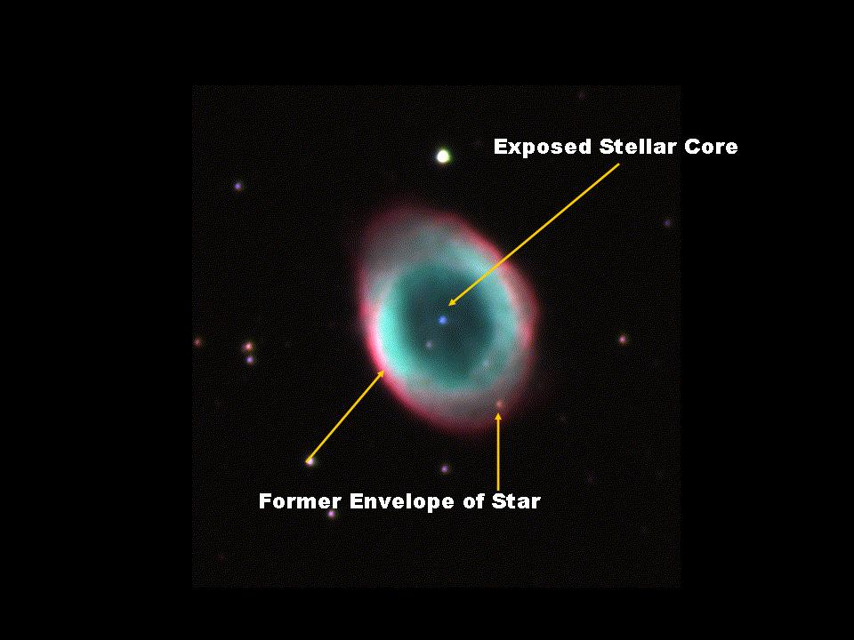

The blue star in the center of the nebula is the hot carbon core. The green ring is the now ionized outer layers of the star being blown away from the core

Structurally the star is schematically represented as follows:

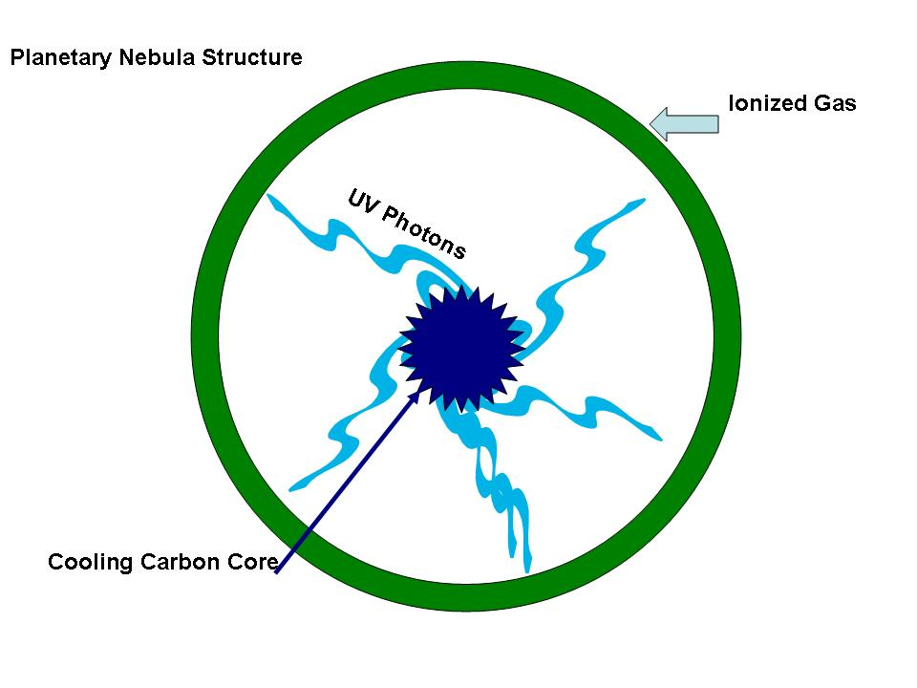

This particular stage of stellar evolution, that is, when the energy source is double shell burning, is very fast (lasting only a few hundred thousand years). However, this particular stage of stellar evolution also has one of the worst misnomers in all of science. When these objects were first discovered with eyeball observations using small telescopes in the 18th century they appeared to be similar to the fuzzy telescopic images (at that time) of planets. Hence these objects were called Planetary Nebulae even though the objects themselves have nothing whatsoever to do with planets or planetary formation. A better terminology would be to call them Post Red Giant Nebulae, but that hasn’t caught on.

Eventually those outer layers of the star (what used to be the hydrogen envelope) will disperse into the ISM leaving behind only the hot stellar core. For low mass stars (mass less than about 4 solar masses), the remaining core mass in insufficient to generate a temperature high enough to ignite carbon fusion. Hence this core will never be able to fuse carbon and it will just continue to shrink until it is stabilized by electron degeneracy. This configuration is known as a white dwarf and we will study this later in the section on stellar remnants. High mass stars, however, will have sufficient core mass to fuse carbon and the overall result of that will be a spectacular explosion (a Supernova) and a collapsed very dense core known as a neutron star. If only low mass stars ever formed, the heaviest element which could be created by fusion is Oxygen. So, where did the gold come from? How come we have economics? The answer will be Supernova.

In summary, stellar evolution is really driven by two things:
- the need to find another energy source when the core of the star has been converted from a light element to a heavy element.
- The interplay between pressure and gravity.

When a star is fusing energy in its core, it is stable. When the core is collapsing to reach a new equilibrium configuration, the heat from that collapse supports shell burning and the envelope of the star expands. Each new phase of stellar evolution is marked by a shorter duration as each is supported by a higher core temperature thus causing a higher nuclear reaction rate and the rapid loss of available fuel. For low mass stars like the sun, their evolution consists of 5 basic stages as summarized in the table below:

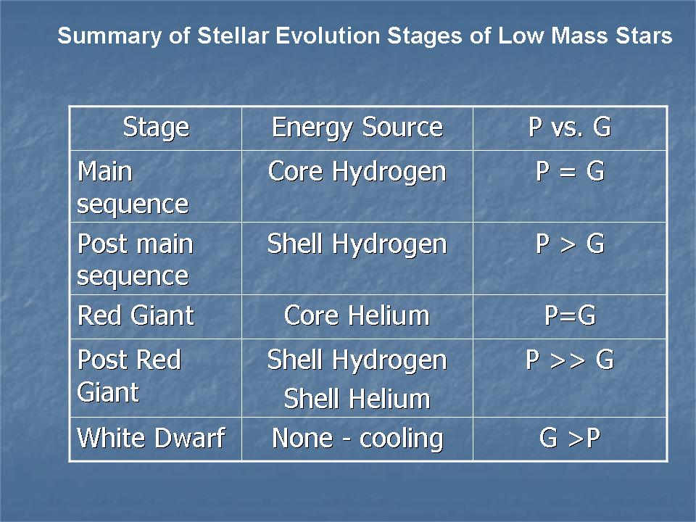

The appearance and change of position of the star in the HR diagram in these evolutionary stages can be followed here: http://opencourse.uoregon.edu/pub/astr122/hrevol.pps

This is resource is a click through animation and is not narrated. Only click on the power point show when instructed to click.

