Supernova and the Periodic Table of Elements:
The kinds of elements which can be formed in stars depends upon their mass. Low mass stars like the Sun will never generate high enough core temperatures to fuse anything heavier than carbon (due to insufficient mass - lower mass stars require lower core temperatures to maintain pressure equilibrium ). Thus element production stops at carbon (plus some nitrogen, oxygen and neon) in these stars. However, stars with main sequence masses greater than about 10 solar masses can fuse elements all the way up to iron.

After the red giant phase of stellar evolution the core of the star has been converted to Carbon/Oxygen. Carbon fusion requires a temperature of about 500 million degrees and thus most stars will have insufficient mass to generate this kind of core temperature and element production ceases. However, if the core of the star is sufficiently massive then carbon fusion can occur through three different pathways:

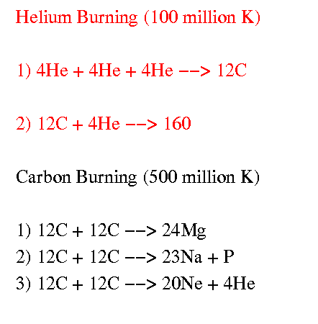
Carbon fusion can go directly to Magnesium or indirectly to produce Sodium and Neon (with a leftover helium nucleus). Often times that left over helium nucleus fuses directly with Magnesium to form element number 28: Silicon. In addition, Silicon can be produced from the direct fusion of Oxygen. These multiple pathways to Silicon production make it a relatively abundant element in the Universe and hence it’s no surprise that the abundance of Silicon on the Earth is also large – in turn this has built a world wide semi-conductor technology. Indeed, because of the helium nucleus that is generally available for fusion, elements in the periodic table of elements that are divisible by 4 are higher in abundance than nearby elements. Thus there is more of element 32 in the Universe (sulfur) than element 31 (potassium) or element 33 (chlorine).

The fusion of silicon requires a temperature of 2 billion degrees. The fusion of silicon ultimately produces a nickel-iron core in the star.

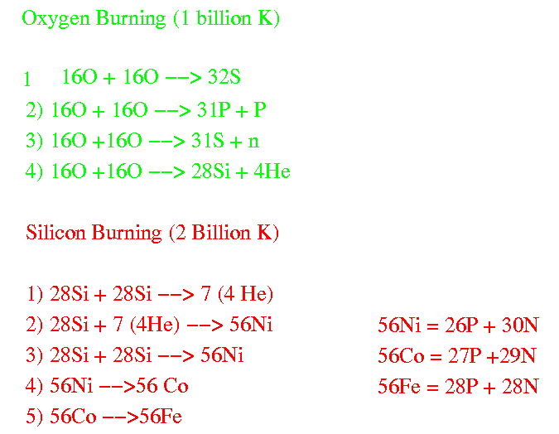

As a result of the fusion of these different elements, the internal structure of the star takes on a layered appearance with different “shells” fusing different elements as shown below:

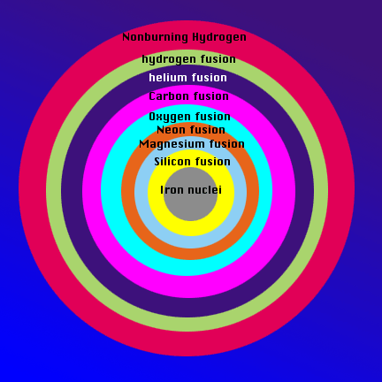

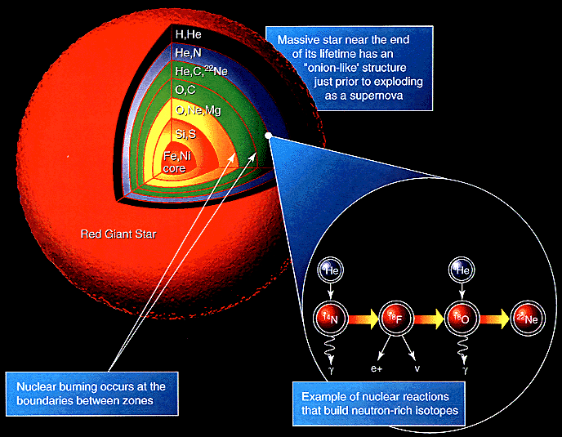
http://helios.gsfc.nasa.gov/onion.gif; http://imagine.gsfc.nasa.gov/docs/teachers/lessons/xray_spectra/images/onion2.gif

Note that the above diagrams are not to scale. In reality the radius of the iron-nickel core is about 1 earth radii but the radius of the star itself is about 5 AU (i.e. the distance from the Sun to Jupiter).

What happens next, after the star has achieved this layer structure, is still not completely understood in physical detail. What we do know, however, is that an iron-nickel core is extremely unstable and a violent runaway effect will now occur via the following steps.

- Iron is an unstable element when it tries to fuse – prior to previous fusion reactions which were exothermic (they release energy) – iron fusion is endothermic (it absorbs energy).
- As iron fusion tries to progress more and more of the internal energy of the core is absorbed
- Loss of internal energy means loss of internal pressure support against the self-gravity of the star
- Hence the core collapsed and heats thus increasing the rate of iron fusion thus increasing the rate of core energy absorption thus accelerating the rate of core collapse.

Startlingly, the above sequence, once initiated is thought to take as little as a second to occur. In that one second period the core will collapse down from its radius of 1 earth radii (6400 km) down to about 10 km (and will form a neutron star – see next section). The rest of the star (the envelope) violently rebounds from this rapid core collapse and is literally exploded off the core of the star in nature’s most energetic event that is currently known. The energy released during the supernova explosion is tremendous and for a period of a few weeks, a supernova (a single exploded star) has an intrinsic brightness of about 10% of an entire Galaxy. Thus, when supernovas occur in other galaxies, they are generally easily detectable from ground based observations. Below is an example of a bright supernova in another galaxy:

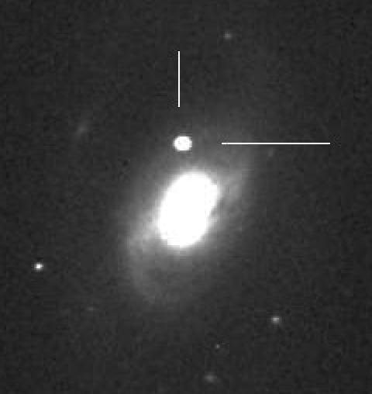

After the supernova explodes, the envelope of the star is violently ejected into interstellar space. That envelope is enriched in heavy elements (see next section) and in a very real sense, seeds the ISM with new, enriched material out of which new stars and planets are formed. This exploded debris is called a supernova remnant. Images of two such remnants in our galaxy from Supernova that occurred 1000 and 400 years ago are shown below. As discussed in the last module, these entitles are the physical mechanism that allows life to exist in the Universe as the filaments are enriched in all the elements that form the Periodic table of elements. For instance, the entire gold content of the Earth is produced during a supernova explosion.

