The Stellar Graveyard

We have previously been discussing stellar structure in terms of a balance between internal gas pressure and the self-gravity of the star. Logically speaking, however, there will come a time when the stellar core is no longer generating any energy at all and so that core is not able to use gas pressure as a form of stabilization against gravitational collapse. Thus some other source of pressure must come into play in order to provide pressure support against gravitational collapse. The Earth is a good example of another form of pressure. The Earth is not collapsing because the self-gravity of the Earth is opposed the crystalline nature of the solid material that compose the earth (i.e. rocks). The bonds/forces between the atoms in a solid (like a rock) are quite strong and a large amount of external pressure would be required to crush a rock. So perhaps it’s possible that stellar cores evolve to some crystalline/solid form of carbon (i.e. a diamond) in order to avoid complete gravitational collapse. We shall see that, qualitatively, this idea of a crystalline structure for a stellar core is accurate, but quantitatively the stellar core will become many times denser than any conventional solid.

Basically there are three possible end points of stellar evolution depending upon the remaining mass of the core after thermonuclear fusion has ceased. These points are

White Dwarf: Core Mass < 1.44 Solar Masses

Neutron Star: Core Mass: 1.44- 3 Solar Masses

Black Hole: Core mass > 3 Solar masses

We will discuss each of these strange configurations of matter in turn, starting with the white dwarf star.

A white dwarf being is life as the hot and luminous central star of a Planetary Nebulae as shown previously. But this state does not last very long and the central star rapidly cools down and its luminosity drops by a factor of at least 1000. At this point the star is a true white dwarf that is supported by the degenerate pressure of electrons and is on the white dwarf cooling sequence. If we refer back to the HR diagram made for the ground based sample of stars with parallax measurements then the white dwarf cooling sequence is shown by the oval region which contains a few dozen nearby white dwarf stars.

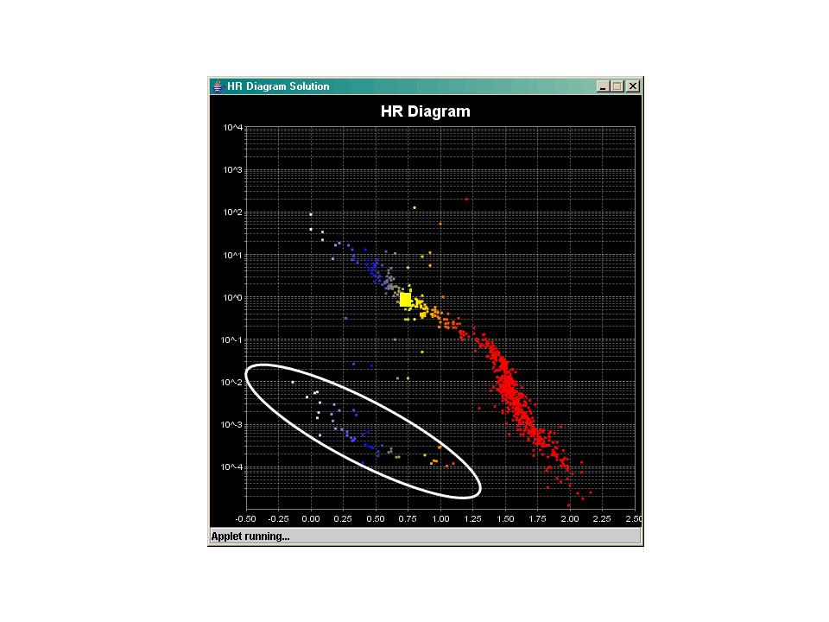

Generally speaking, all stars with main sequence masses less than 5 solar masses will end up becoming white dwarfs because there is so much mass loss during the various phases of stellar evolution following hydrogen core exhaustion. Measuring the current mass of a white dwarf, therefore, does not indicate what its initial mass was. A 0.5 solar mass white dwarf could have easily started out life as a 10 solar mass main sequence star.

A white dwarf star is therefore the remnant carbon/oxygen core of a former main sequence star. All of the hydrogen and helium that used to be in the star has been lost in the Post Red Giant phase of stellar evolution. White dwarfs usually have masses between 0.5 and 1 solar mass and have collapsed down to the size of the Earth. Thus their densities are extremely large, on order of 1 million to 10 million times the density of water. So a gallon of white dwarf would weigh roughly 80 million pounds! What strange matter this must be. Indeed, we can not even come close to producing material this dense on the Earth.

Now when matter gets to extremely high densities some very peculiar physical laws begin to govern its behavior. In particular, in a normal gas, when you heat it, not only do the particles move faster but the gas tends to expand. If the gas is confined (i.e. by the self-gravity of the stellar core) then the gas pressure rises and it rises in direct proportion to the temperature. But for white dwarfs, the carbon-oxygen “gas” is incredibly dense (10 tons per cubic centimeter) and it’s the density of the material that will determine the gas pressure and not the temperature. This occurs because of a quantum mechanical condition called the Pauli Exclusion Principle that holds for electrons. The meaning of this exclusion principal is as follows: no two electrons can occupy the same energy state at the same time in the same place. Since the electrons are packed so tightly together, they are always at the “same place” and therefore all the lower energy states of the electron gas are filled. The left over electrons (and there are lots of them) have no choice but to occupy a higher energy state. This causes their velocity to increase just the same way that increasing the temperature of an ordinary gas causes the velocity of the particles to increase. In this case, it’s the high density that is causing the electrons to automatically move into higher energy/higher velocity states. Gas pressure increases with increasing particle velocity and therefore the pressure of a degenerate gas of electrons is determined by its density.

This then leads to the inverse mass-radius relation for white dwarfs. A 1 solar mass white dwarf has a smaller radius than a 0.5 solar mass white dwarf, because a 1 solar mass white dwarf requires a higher pressure for stabilization and a higher pressure requires a higher density of matter – thus the radius is less. Remember, the density of a spherical object is essentially M/R³. Hence in white dwarfs:

internal pressure is independent of the temperature

further compression of the white dwarf does not lead to heating (as it does for the normal collapse of a stellar core)

a fully degenerate electron gas then can support the white dwarf against further collapse

A white dwarf is therefore a stable star (no further gravitational contraction) that is simply cooling off and producing no additional energy of its own. After billion of years, the white dwarf will cool down so that it no longer emits much light in the optical part of the spectrum. The timescale for this to occur is longer than the age of the Galaxy so this configuration has not yet been reached.

Neutron stars:

The theoretically maximum mass that can be supported by electron degeneracy is 1.44 solar masses. So let’s assume that we have a 1.44 solar mass white dwarf star that is perfectly stable. What happens if we had .01 solar masses to it? Well, we are then on our way to a new state of matter. If the mass of the remnant core exceeds 1.44 solar masses, electron degeneracy breaks (this basically means that the electrons can’t exist anymore). Such a configuration can occur during the core-collapse of a Nickel-Iron core that produces a supernova. In that case the core collapse is very rapid and violent and the protons and electrons literally are fused together to form neutrons. The resulting core becomes, essentially, a ball of neutrons which is stabilized by a degenerate gas of neutrons (instead of electron degeneracy in the case of white dwarfs). This state of matter is also called neutronium. Neutron degeneracy occurs at extremely high densities (essentially the density of an atomic nucleus) of 10¹⁴ grams per cubic centimeter (100 million tons per cubic centimeter). In order to obtain these high of densities, the core must collapse down to a radius of only 10 km! One consequence of this huge collapse in radius is that, if the stellar core were rotating even slightly prior to the collapse, by the hand of the collapse it is rotating very rapidly in order to conserve angular momentum. Thus a neutron star has these properties:

Remnant of a massive star (post supernova core)

Supported by Neutron Degeneracy

Maximum mass is 3 solar masses (most are 1.5-2 solar masses)

Radius 10-20 km

Density = nuclear densities

Very rapid rotation = can spin several thousand times per second.

The structure of a neutron star is thought to look something like this:

http://science.nasa.gov/newhome/headlines/mag_pix/TV-graphics/xsection.jpg

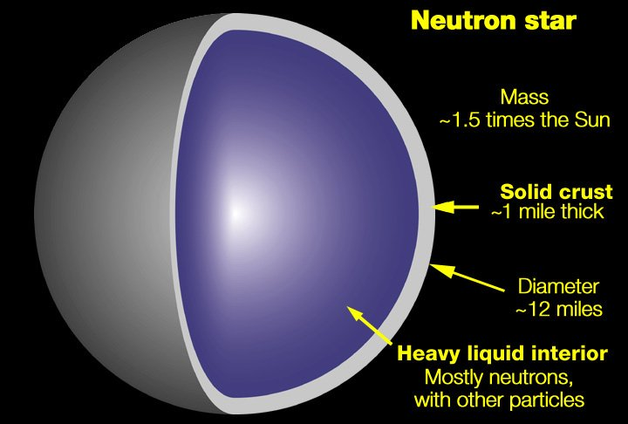

In which there is a mixture of solid and liquid states of dense material. A shift in the solid crust would cause a star quake and there is actually a mechanism for detecting these strange phenomena. This solid crust is thought to be composed of iron or possibly is a several hundred meter thick lattice of neutrons that is acting like a crystalline solid – no one is really sure.

However, you might think that an object (a remnant stellar core) of only 10 km would be impossible to observationally detect as it wouldn’t emit very much light. However, the structure of a neutron star is such that it contains a very powerful magnetic field. It has been known since the 19th century that electrons, when accelerated in a magnetic field, will produce light. Thus free electrons that are caught in the magnetic field of a pulsar can emit light – furthermore that light is emitted only at the respective poles of the magnetic field. In addition, of course, the neutron star is rapidly rotating. Hence, if the neutron star is favorably oriented so that the observer is looking down the magnetic polar axis of the rotating neutron star – they will observe a pulse of emission with each rotation. Such objects (initially discovered in 1974) clearly exist and are known as pulsars. A pulsar is a rapidly rotating neutron star.

The overall structure of this situation is complicated and is schematically shown below:

http://science.nasa.gov/newhome/headlines/mag_pix/pulsars.jpg

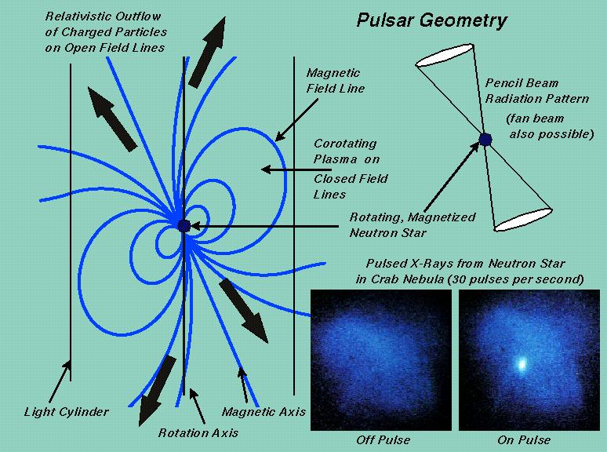

The important concept here is in the top right of this diagram which shoes this cone of emitted radiation emerging from the magnetic polar axis. This radiation can be in the form of radio, optical or x-rays and usually all three sources can come from a single pulsar. The Crab nebula, the core remnant of a supernova that occurred in 1054 AD and was visible in the daytime sky for 2-3 weeks, is rotating 30 times per second. Thus, much like a lighthouse, each time that cone of radiation sweeps by us, the observer, we see a short pulse of emission. These pulses are emitted on an extremely regular basis (making pulsars the most accurate astronomical clock that exists). A star quake, or shift in the internal structure of the neutron star, causes a significant change in the rotation properties and even the orientation of the magnetic field lines. Enough pulsars have been observed over time to detect this sudden change in the pulsar emission profile thus signaling the star quake event.

But what now happens if the remnant core mass exceeds 3 solar masses so that even neutron degeneracy breaks? Well, there is no other known source of pressure so, in principle, that object collapses down to a structure with zero radius and infinite density. Does Nature really allow that to happen?

